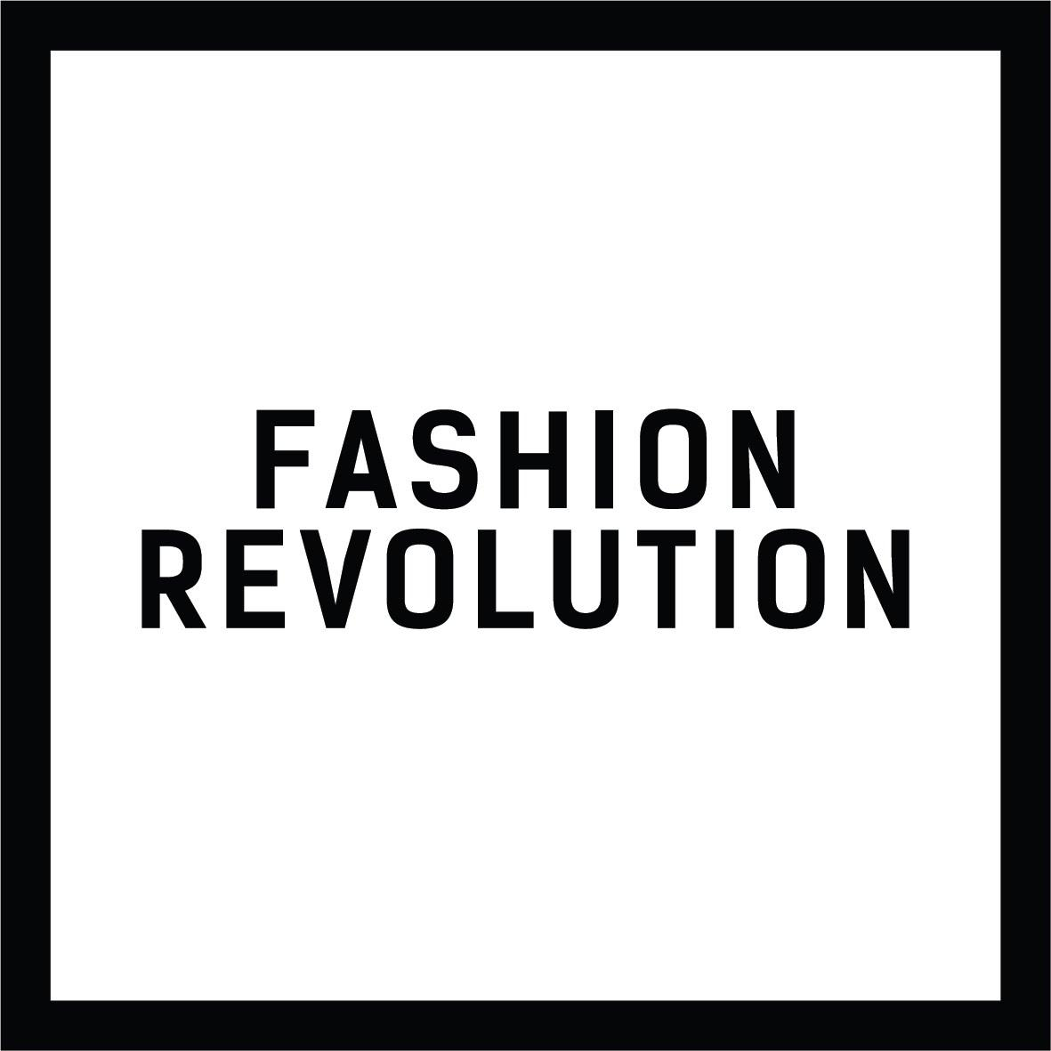

Fashion Revolution responds to Alison Levitt QC’s independent inquiry into Boohoo Group PLC & Leicester factory conditions

What were the biggest findings?

The investigation found that allegations of unacceptable working conditions and underpayment of workers are substantially true across the majority of their supply chain and that Boohoo’s monitoring of its Leicester supply chain has been inadequate for many years. The report says the Directors did not act quickly enough to address these issues because they prioritised the wellbeing of their shareholders over the wellbeing and fundamental human rights of their workers. Today’s financial results show strong revenue growth, up 45% across all geographies and brands.

Alison Levitt QC said that although the company has not committed any criminal offences, senior members of Board knew for a fact that there were serious examples of unacceptable working conditions, including critical health and safety violations and a high risk of fire, illegally low pay, excessive working hours, and many employees do not have proper contracts and are not entitled to statutory paid holidays or sick pay.

She concluded that Boohoo has not felt any real sense of responsibility for the factory workers in Leicester because they are largely invisible to them. Not only does Boohoo not publish their supplier lists, but it is clear that they don’t know who many of their estimated 500 Leicester suppliers are and are therefore unable to carry out even basic due diligence. This is why Fashion Revolution is calling for greater transparency in the fashion industry, because exploitation thrives in hidden places and if you can’t see the problems, you can’t fix them.

Is the Boohoo’s response satisfactory?

Boohoo begin their response by underlining their commitment to increase transparency and they certainly have a long way to go in this respect, scoring just 9% in this year Fashion Transparency Index which ranks and reviews 250 of the world’s biggest fashion brands.

Depending on the speed at which they implement the measures detailed in their action plan, they appear to be focusing in some, although not all, of the right places: corporate governance, purchasing practices, raising supplier standards and ensuring garment workers’ rights. We particularly welcome their decision to publish the full list of tier one and tier two UK suppliers which is something we at Fashion Revolution, alongside other organisations, have been calling for. In the traceability section of this year’s Fashion Transparency Index, Boohoo scores zero.

Publishing this information will help unions and civil society groups to remediate problems faster and clarify when unauthorised subcontracting occurs in the brand’s supply chain, something Boohoo claim happened amidst allegations in July. It can also enhance investor and consumer trust in the brand, showing stakeholders that brands are willing to be open and honest about where their products are being made. But the lists will only be published once the audits are complete, which begs the question, what have they got to hide?

Their response makes no mention of the role of trade unions, and freedom of association for the workers which are key in ensuring their rights. There is also no mention that supplier assessments will include offsite worker interviews to get a true picture of life inside the factories. The investigation received no responses from union members, with one witness stating they believed there were no unions.

UK Parliament’s Environmental Audit Committee has expressed concern about Boohoo’s failure to establish trade union recognition within its own operations. The Committee recommended that Boohoo engage with the Union of Shop, Distributive and Allied Workers, (Usdaw) as a priority and recognise unions for their workers. In a letter to the Group Executive Director, Carol Kane, and Group Executive Chairman, Mahmud Kamani, on 15 July 2020, the Chair of the Committee reports that “Boohoo will not formally recognise Usdaw, have refused to meet union representatives and will not engage with Usdaw despite [EAC’s] recommendations”.

Boohoo also need to disclose how they proactively identify human rights and environmental risks, impacts and violations in its supply chain on an ongoing basis. Meaning, the group must share their approach to conducting due diligence, rather than relying on auditing as the sole method of managing supply chain compliance. The EAC recommended that Boohoo should join the Ethical Trading Initiative (ETI) who say that Boohoo have since joined an alternative organisation and it is their understanding that “this alternative is an audit-based body that does not have a progression framework and does not hold its members to account”.

Did the report go far enough?

No. Alison Levitt concludes that she is confident that the adaptations which Boohoo should make involve a relatively easily-achieved realignment of its priorities and governance systems. We have been putting a sticking plaster on this wound for far too long. The fast-fashion business model needs deep systemic and structural change to reduce its myriad of negative social and environmental impacts and we are fooling ourselves if we think this is going to be easily achieved.

As a first step, Boohoo needs to disclose more information publicly so they can be held to account. Their code of conduct is basic, for example:

- Wages and benefits paid for a standard working week meet, at a minimum, national legal standards or industry benchmark standards, whichever is higher. In any event wages should always be enough to meet basic needs and to provide some discretionary income
- All workers shall be provided with written and understandable Information about their employment conditions in respect to wages before they enter employment and about the particulars of their wages for the pay period concerned each time that they are paid.

There is no detail in these policies and no information about how they are to be put into practice. Contrast this, for example, with another UK fashion retailer, TopShop who have a four-part guidebook running to several hundred pages, with in-depth procedures on health and safety requirements and working practices on selected strategic labour topics.

The report recommends Boohoo should consolidate their business and terminate relationships with suppliers who do not meet the audit standards, rather than working with them collaboratively and proactively to address and remediate the issues identified, and putting a responsible exit policy in place where the supplier fails to improve. This recommendation may help to protect Boohoo’s reputation, but it does little to protect the jobs of vulnerable workers at this time of economic downturn.

One of the most astonishing recommendations is that Boohoo should consider “slightly repositioning” the narrative of its branding and aim to be “the first choice for the fashionable and thrifty young woman with a social conscience and who cares about the environment”. However, the report makes no mention whatsoever of how they should go about minimising the environmental impact of their clothing, essentially suggesting that they engage in greenwashing. Boohoo cannot reposition itself without a radical overhaul of the way they produce their clothes. The fashion industry needs to cut its emissions in half by 2030 to align with the 1.5 degree celsius pathway. Globally, around two thirds of our clothing is made from synthetic fibres derived from fossil fuels, and it seems likely that the percentage is far higher than this at Boohoo. Many of the garments produced by Boohoo are effectively single use plastic. Synthetic textiles also account for 35% of global microplastic pollution. There is no mention at all in Alison Levitt QC’s report as to how she suggests Boohoo will reduce their environmental impact. Boohoo need to choose better materials which don’t generate massive environmental impacts, leak microfibres into our oceans and compromise human health and nature’s ecosystems and there is no indication that they are willing to do so.

How is this issue systemic?

This is a widespread issue stretching back at least a decade. In 2010 a Channel 4 Dispatches programme revealed dangerous sweatshop conditions in Leicester workshops supplying major high street brands. They returned in 2017 and found that factories making clothes for Boohoo, amongst other brands, were underpaying workers and exposing them to unsafe conditions and regular intimidation. Boohoo responded by saying wanted to help raise safety standards and ensure they paid at least the minimum wage.

Last year, HomeWorkers Worldwide published the results of a survey they carried out across 182 garment and textile factories in Greater Manchester. They found workers were being paid £3-4 an hour, some were undocumented migrant workers, and many had no permanent contracts, echoing the conditions found in Leicester’s garment factories.

Almost all the information published by Boohoo about their supply chain is found in their modern slavery report, highlighting the importance of mandatory reporting legislation. Alison Levitt says that Inaction by the authorities has contributed significantly to the deficiencies she has found, and it is evident that existing laws need to be enforced. However, it is also clear that the existing laws are not sufficiently robust. Ultimately, we need to make directors legally responsible for conditions throughout their supply chains and we believe that mandatory corporate human rights due diligence legislation is an essential next step. The scope of the recently introduced loi de vigilance in France covers the activities of subcontractors and suppliers with whom a company has an established commercial relationship and this sort of legislation is essential if we are to see real change, particularly amongst the laggards in the industry. Under French law, Boohoo directors would have been held legally responsible for the many human rights abuses identified in their supply chain.

For more information please contact Carry Somers carry@fashionrevolution.org

