#WhoMadeMyClothes
#IMadeYourClothes
#FashionRevolution
Press Release
April 2019
SAVE THE DATE
FASHION REVOLUTION WEEK 2019
22 – 28 April
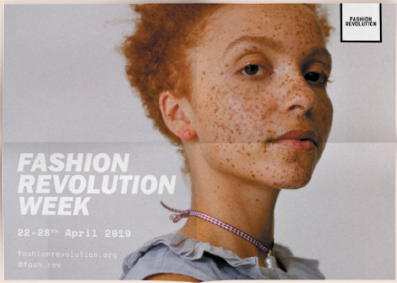
Fashion Revolution Week, the annual global campaign calling for a fairer, safer, more transparent fashion industry, will run from Monday 22nd – Sunday 28th April 2019.

This year Fashion Revolution Week will highlight how the future fashion industry must respect both people and planet with fair and decent work, environmental protection and gender equality. The campaign will be supported by Jasmine & Melissa Hemsley, Wilson Oryema, @dresslikeamum and Stories Behind the Things to urgently demand a fashion industry that conserves and restores our environment and gives people, especially women, a voice.
From Australia to Brazil, Uruguay to Vietnam, more than 275 million people are again expected to take part in Fashion Revolution Week by asking brands #whomademyclothes. Over 1,000 Fashion Revolution events will be held in over 100 countries around the world, from catwalks and clothes swaps, to film screenings, panel discussions, creative stunts, open studios and workshops.
The week will kick off on Earth Day highlighting the devastating impact of the fashion industry on global warming, offering positive actions we can all take to reduce the carbon footprint of our clothes. We will also be hosting the annual Fashion Question Time at the Houses of Parliament and the launch of this year’s Fashion Transparency Index, the biggest yet, with a listing of 200 brands.
While the sustainability of the fashion industry is increasingly under scrutiny, human rights abuses, gender inequality and environmental degradation remain rife. Research shows that garments are among the items most at risk of being produced through modern slavery. Sexual harassment, discrimination and gender-based violence against women is endemic in the global garment industry, where women comprise 80% of the global workforce. Global textiles production emits 1.2 billion tonnes of greenhouse gases annually, more than international flights and maritime shipping combined. We are producing 53 million tonnes of fibres to make clothes and textiles annually, only to landfill or burn 73% of those fibres.
Orsola de Castro, Co-founder and Creative Director said: “For Fashion Revolution Week 2019 we will be campaigning for a fashion industry where dignity in work, gender equality and environmental protection is the standard and not an exception, because we see the need for greater transparency across these three interrelated topics.”
Fashion Revolution Week 2019 will encourage people to recognise their own personal impact and value quality over quantity. It will demand a change in culture where we value dignity in work because we cannot afford to live in a world where our clothes destroy the environment, harm or exploit people and reinforce gender inequality.
Carry Somers, Co-Founder and Global Operations Director of Fashion Revolution said: “Every time we buy, wear and dispose of clothes, we create an environmental footprint and an impact on the people who make them, most of whom are women. That’s why positive change is more urgent than ever if we are to tackle climate change and create a more equitable future for all.
To find out what’s happening in your area this Fashion Revolution Week or to find out more about the campaign, visit www.fashionrevolution.org .

– ENDS –

Download images for press here and credit where appropriate. For any alternative images, please request from press@fashionrevolution.org.
For more information, images, interviews and footage, contact: press@fashionrevolution.org 07886 301486.

Notes to Editors
Fashion Revolution is a global movement that works for a more sustainable fashion industry, campaigning for systemic reform of the industry with a special focus on the need for greater transparency in the fashion supply chain. Fashion Revolution is a non-profit organisation with a presence in over 100 countries around the world. Our vision is a fashion industry that values people, the environment, profit and creativity in equal measure. Fashion Revolution works all year round to raise awareness of the fashion industry’s most pressing issues, advocate for positive change, and celebrate those who are on a journey to create a more ethical and sustainable future for fashion.
Fashion Revolution Week is the annual campaign of the Fashion Revolution movement. Over the years we have been joined by hundreds of celebrities and influencers including internationally-recognised names such as actress Emma Watson, pro-surfer Kelly Slater, artist Shepard Fairey, editor-in-chief of Marie Claire Italia Antonella Antonelli, Brazilian actress Fernanda Paes Leme, Nobel Prize Winner Professor Yunus and cooks Jasmine and Melissa Hemsley, and Bangladeshi ex child worker Kalpona Akter.
In a recent Fashion Revolution consumer survey, more than one in three people said they consider social and environmental impacts when buying clothes. We need a bigger and faster cultural shift so that all people buy and use clothes more mindfully.
84% of respondents said that fashion brands should be tackling global poverty and 85% said that fashion brands should be tackling climate change. 72% of the public said that fashion brands should do more to improve the lives of the women making their products and 80% said that fashion brands should disclose their manufacturers.
The majority of respondents (68%) agreed that the government has a role to play in ensuring that clothing is sustainably produced. Three-quarters of people agreed that fashion brands should be required by law to protect the environment at every stage of production, while 77% agreed that fashion brands should be required by law to respect the human rights of everyone involved in the making of their products.

SOURCE?

