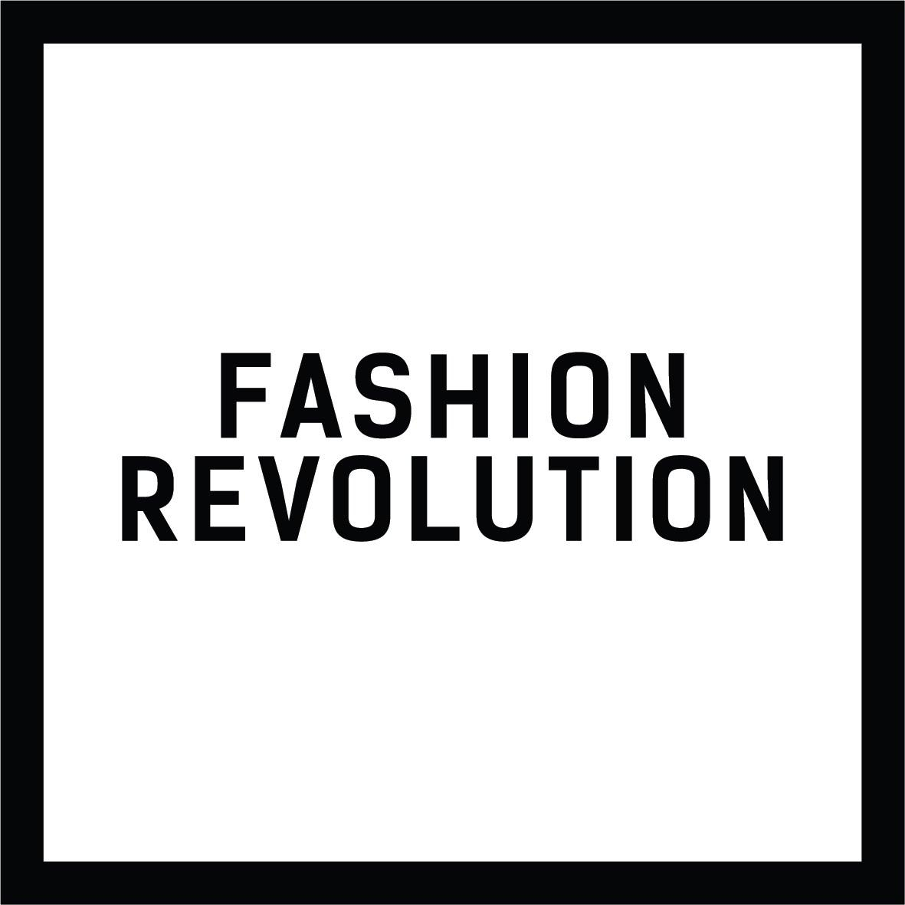

PRESS RELEASE

UNDER STRICT EMBARGO 11 OCTOBER 2018

First edition of Fashion Revolution’s Brazilian Fashion Transparency Index launches
A new report published today analyses the extent to which twenty major fashion brands and retailers are disclosing their social and environmental policies, practices and impact. The Fashion Transparency Index Brazil was jointly commissioned by the Brazilian and global Fashion Revolution teams.

The research was carried out by Fashion Revolution Brazil in partnership with the Centre for Sustainability Studies at Getulio Vargas Foundation (FGVces) and was based on information publicly disclosed by brands and retailers via corporate social responsibility websites, sustainability and annual reports. Each brand was also sent a questionnaire of almost 200 questions to engage them in the process.

The team reviewed the selected brands transparency disclosures and benchmarked their performance on five key issues: policy and commitments, governance, traceability, know show and fix, and spotlight issues. The brands included in the Fashion Transparency Index report are:: Animale, Brooksfield, C & A, Cia. Marítima, Ellus, Farm, Havaianas, Hering, John John, Le Lis Blanc Deux, Malwee, Marisa, Melissa, Moleca, Olympikus, Osklen, Pernambucanas, Renner, Riachuelo and Zara.

Commenting on the research findings, Eloisa Artuso, Project Manager and Director of Education at Fashion Revolution Brazil explains that there is still a long way to go before the industry can claim to be transparent:

"Information about supply chains is often hidden on websites, or hosted on external websites that are difficult to find, in annual reports of more than 300 pages or simply not available. How can we make better decisions about what we buy, when information is either totally absent or presented in such varied and long winded ways?”

Quick Findings

Of the 20 major Brazilian fashion brands and retailers surveyed, eight lacked transparency, scoring 0% overall. This does not necessarily mean that they do not have good practices and initiatives, but that at the time of the research they did not disclose any information about their social and environmental policies, practices or impacts.

The Fashion Transparency Index is a project that was first initiated in 2016 by Global Fashion Revolution, the third edition of which was published in April 2018, when 150 major global brands and retailers were reviewed and ranked, achieving an average overall score of 21% (52 of 250 possible points). In the Brazilian Index, the average overall score was 17%, or 42 out of 250 possible points).

Four brands that were featured in the 2017 Global Fashion Transparency Index - C & A, Casas Pernambucanas, Renner and Zara - showed an average year-on-year improvement of 38% in their levels of transparency. This may be an indication of how the Index encourages brands to publish more information about their social and environmental policies, practices and impacts.

Some of the conclusions drawn by the annual Global Fashion Transparency Index reports were also reflected in the Brazilian analysis. Brands and retailers give a lot more time and space to explain their values and beliefs rather than their actual practices and real-life impacts. For example, 12 brands and retailers scored higher for human rights, anti-discrimination, and forced or child labour policies, whereas only seven scored in the area of traceability.

On environmental policies and practices, only two brands report on policies on carbon emissions and energy reduction, three disclose policies on biodiversity, six publish policies on water effluent treatment, and six disclose policies on waste management and recycling.

The intention is for the Index to be widely downloaded and become a useful tool for all, closely monitoring current levels of transparency and how brands disclose more information over time.

"We want to emphasize that the reader should uses the findings of the Index to reflect on general trends of transparency and disclosure patterns, rather than focusing on which brand scored highest," concludes Eloisa

Aron Belinky, leader of FGVces research team who worked on the project, highlighted the report's potential as a catalyst for change:

"We hope that the first edition of FTI Brazil will encourage Brazilian companies to communicate how they manage their business and the impacts of its operations, and also to open a dialogue with its stakeholders. Such initiatives serve as a model and inspiration for other sectors of the Brazilian economy, with challenges that reflect those faced by the the global fashion industry.”

The Fashion Transparency Index Brazil had institutional support from the Brazilian Textile Retail Association (Abvtex) and is funded by C&A Foundation. The project is open for future co-financing, provided that measures necessary to ensure its autonomy and neutrality are observed.

The report will be launched at an event in São Paulo featuring Carry Somers, co-founder of the Fashion Revolution movement, who will be in Brazil to talk to the media about the project.
Download the report at: https://www.fashionrevolution.org/about/transparency/
We kindly ask that the link be included in any article
- ENDS -
For more information:
Brazil: Gabriela Machado André
frd.assessoria1@gmail.com / (11) 9486-08557

Global spokespeople: Sarah Ditty, report author and Policy Director and Carry Somers, Fashion Revolution Co-Founder press@fashionrevolution.org .

