Press Release

6th July 2018

Fashion Revolution launches pre-orders of its bi-annual fanzine Issue #003:

FASHION, ENVIRONMENT, CHANGE

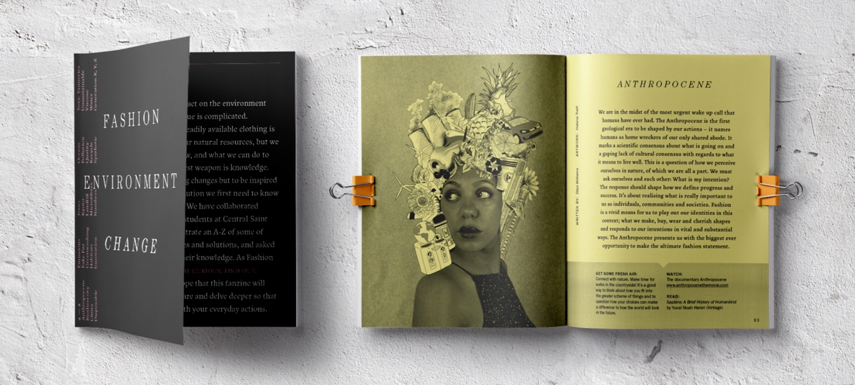

Review copies available for journalists upon request.

On 28th August, Fashion Revolution is launching the third in a series of its bi-annual collectible fanzines which seek to uncover the stories behind the clothing we wear.
FASHION, ENVIRONMENT, CHANGE is an A -Z of the fashion industry’s thorny relationship with greenhouse gases, ocean plastics, and textile pollution, from the Anthropocene to Generation Z. In order to make change, we need to understand the problems and find creative ways to change systems and human behaviour.
The Graphic Design students of Central Saint Martins have created thought provoking illustrations and visuals to give a fresh perspective on the carbon footprint of a pair of jeans; the corrosive pollution created by the textile factories of Erode in India; and why shoe and bag brands need to get to know their tanneries.

A team of experts, writers, poets and campaigners examine how fashion can lessen its impact on the planet for future generations. Contributors include Dilys Williams, Linda Greer, Wilson Oryema, Orsola de Castro, Scarlett Conlon, Jake Hall, Tamsin Blanchard, Carry Somers, Sarah Ditty, Fleur Britten, Matthew Neadham and Arizona Muse.

Orsola de Castro, co-founder of Fashion Revolution said: “Demanding accountability is the next frontier. We need to look at a fashion horizon that goes beyond just loving a brand because it looks good, but trusting it because it does good.”

Lilian Liu, CSR Fashion Manager of Partnerships at united Nations Global Compact said: “Not only do we waste precious natural resources and energy in creating the textiles, but decomposing fabrics releases methane, a harmful greenhouse gas that contributes to global warming.”

Fashion journalist and editor Tamsin Blanchard said: “Junk food; junk clothes, a generation raised to excess. And where does that leave Generation Z? With a world fat with clothes, a planet gasping for breath. Together we must all clean up the mess, say slow down, we have enough.”
Model Arizona Muse said: “Imagine a world in which every human being regarded water as a sacred element, treated it with respect, guarded it ferociously from our pollution. Imagine if we were all water warriors. What a beautiful world this would be.”
The proceeds of this non-profit fanzine will go towards creating more inspiring and informative resources like this zine in the future and helping to grow the Fashion Revolution movement.
Issue #003: Pre-orders will be available at www.fashionrevolution.org/fanzine3 for £9 + p&p and will be sent out mid-August.
-Ends-
For more information, images or interviews, please contact Martine Parry martine.parry@fairtrade.org.uk 020 7440 7695 / 07886 301 486.
Notes to editors
About Fashion Revolution:
Fashion Revolution is a global movement that works for a more sustainable fashion industry, campaigning for a systemic reform of the industry with a special focus on the need for greater transparency in the fashion supply chain. Fashion Revolution is a non-profit organisation with presence in more than 90 countries around the world. Our vision is a fashion industry that values people, the environment, profit and creativity in equal measure. Fashion Revolution works all year round to raise awareness of the fashion industry’s most pressing issues, advocate for positive change, and celebrate those who are on a journey to create a more ethical and sustainable future for fashion.

The proceeds of this non-profit zine will go towards creating more inspiring and informative resources like this zine in the future and helping to grow the Fashion Revolution movement.
This limited edition fanzine began with Fashion Revolution reaching out through their social media channels to the public and their inspiring community of 'Fashion Revolutionaries’ across the world for creative submissions. The social media movement has also collaborated with some exciting artists and writers to create the incredible content for this publication.
Social media info:
www.instagram.com/fash_rev/
www.facebook.com/fashionrevolution
www.twitter.com/fash_rev
Hashtags:
#fashionrevolution
#lovedclotheslast
Fashion facts and stats
● Global clothing production more than doubled since 2000, exceeding 100 billion garments produced in 2014. [Source McKinsey]
● The average person buys 60% more clothing and keeps the for about half as long as 15 years ago. [Source McKinsey]
● An estimated £140 million worth (350,000 tonnes) of clothing goes to landfill in the UK every year. [Source WRAP]
● In USA, 10.5 million tons of clothing is sent to landfill every year. That’s about 30 times as heavy as the empire state building. [Source: Elizabeth Cline]
● It is estimated that we make 400 billion m² of textiles annually. 60 billion m² is cutting room floor waste. [source Gugnami & Mishra]
You can read more about Fashion Revolution at fashionrevolution.org.

